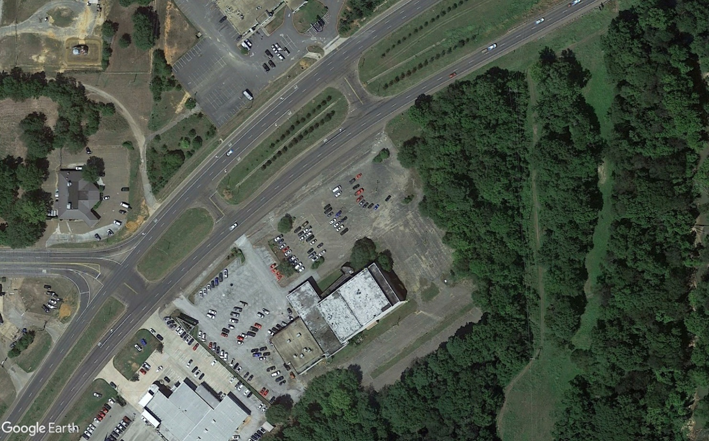
Propane refueling area
Enter propane area
Exit propane area

Propane Refueling Area Address: 720 S US 259 (S. Hwy 31)
(Old Movie Theatre)

Coordinates: 15 S 334966.39 E / 3596174.18 N

No more than 2 people per vehicle allowed in the refueling area.

Strikers must be removed from basket in the refueling area.

